Landline Phone Amplifiers
Landline phone amplifiers allow people with hearing impairment to hear their phone call more loudly and clearly. This device is also helpful to those who use the phone in loud and noisy environments.
Type of accessory: Landline Handset Amplifier
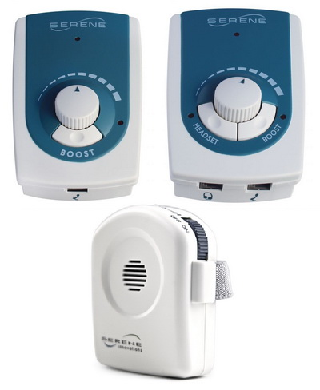

How do you use these accessories?
Connect the amplifier to your landline telephone using a telephone cord or by sliding it onto the handset. Adjust the volume and tone controls until you can hear the incoming call at a louder volume and clearer quality. Adjusting the compatibility control may be needed to ensure amplification.
An example of how to use these accessories can be seen here: Video of Serene amplifier

These accessories connect to phones via:
Audio Jack: No
Bluetooth: No
Wi-Fi: No
Micro USB: No
Other: Landline telephone modular cord (except UA-30 amplifier)

Is there any other piece of equipment required for this accessory to work properly with a phone?
No, it does not require any additional equipment to connect or work properly with a phone.

Compatibility:
These amplifiers work with virtually all landline telephones. Please check with your amplifier supplier to confirm compatibility with your landline phone.

Popular landline phone amplifiers available in Australia:

Serene Innovations Universal Portable Phone Amplifier UA-30

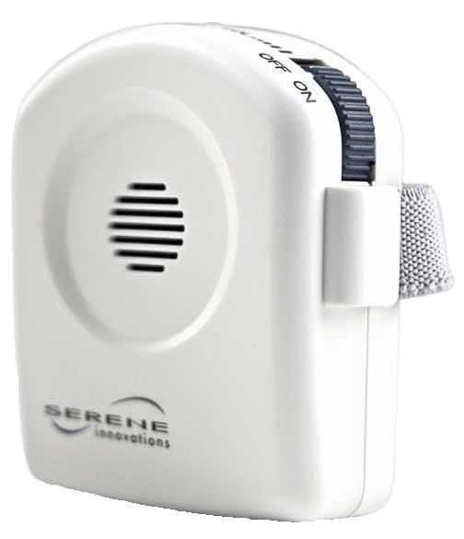
The UA-30 amplifier straps onto any standard, cordless or payphone landline handset. It increases the volume of a phone call by up to 26dB and adjusts the tone to improve speech clarity. It can also be paired with a T-coil hearing aid or implant. This device is compact, lightweight and includes two AAA batteries and a case.
You can buy this accessory from Phoenix Hearing.
More information at:
Universal Portable Phone Amplifier UA-30
Universal Portable Phone Amplifier User Manual (PDF Download)

Serene Innovations Universal Home Phone Amplifier UA-45
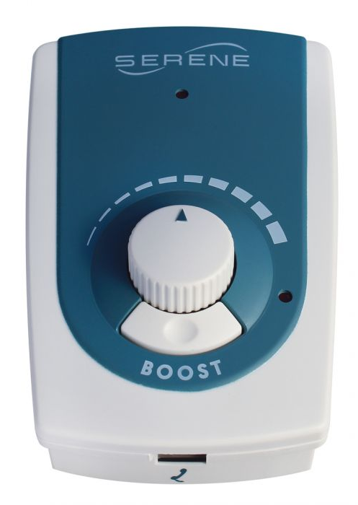
The UA-45 amplifier works with corded landline telephones, connecting between the handset and base. It increases the volume of a phone call by up to 45dB and adjusts the tone to improve speech clarity. This device also removes most unwanted distortion, echo and static.
The volume boost function provides maximum amplification and works by holding down the boost button, lighting the LED when in use. This device features an easy to use rotary volume control, tone and compatibility side switches and an AC adapter jack. This device does not work with cordless telephones and requires a 9-volt battery, which is not included.
You can buy this accessory from Phoenix Hearing.
More information at:
Universal Home Phone Amplifier UA-45 Webpage
Universal Home Phone Amplifier UA-45 User Manual (PDF Download)

Serene Innovations Universal Business Phone Handset/Headset Amplifier UA-50
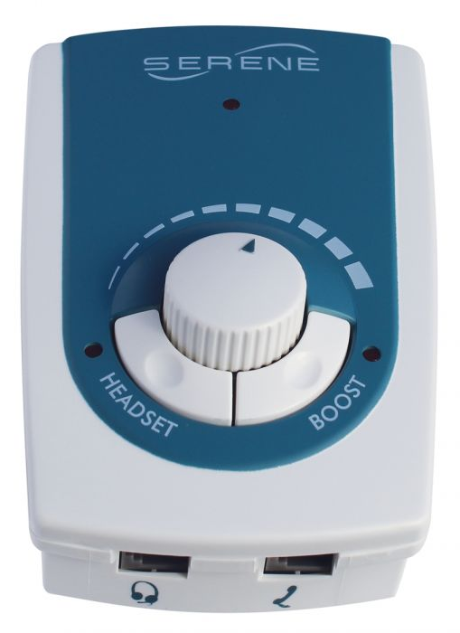
The UA-50 amplifier works with both handset and headset on corded landline telephones, connecting between the handset/headset and base and with a switch to alternate between handset and headset modes. It increases the volume of a phone call by up to 45dB and adjusts the tone to improve speech clarity. This device also removes most unwanted distortion, echo and static.
The volume boost function provides maximum amplification and works by holding down the boost button, lighting the LED when in use. This device features an easy to use rotary volume control, tone and compatibility side switches, an AC adapter jack and a headset jack. This device does not work with cordless telephones and comes with an AC power adapter.
You can buy this accessory from Phoenix Hearing.
More information at:
Universal Business Phone Handset/Headset Amplifier UA-50
Universal Business Phone Handset/Headset Amplifier UA-50 User Manual (PDF Download)

Clarity 40dB In-Line Phone Amplifier
The Clarity In-Line phone amplifier provides hearing support for those with moderate hearing loss. It amplifies the volume of incoming voices up to 40db and can also adjust the tone of a voice. The amplifier can be connected to a landline headset or base.
You can buy this accessory from ALDS.

Is there any training available for these accessories?
Training and demonstrations might be available directly from the retailers.
Some of these accessories might be displayed and available for demonstrations at Independent Living Centre Australia. Please contact ILC by calling 1300 885 886 for further information.

